**THE EVOLUTION OF TECHNICAL EDUCATION AT A LEADING RUSSIAN UNIVERSITY: THE DEVELOPMENT AND IMPLEMENTATION OF PROJECT-BASED LEARNING**

**Nadezhda V. Shatrova, Maria E. Travyanova, Andrey I. Voronin**,

**Andrey G. Yudin, Denis V. Kuznetsov**

National University of Science and Technology «MISiS»

E-mail: [shatrova@misis.ru](mailto:shatrova@misis.ru); [guseva.mari@gmail.com](mailto:guseva.mari@gmail.com)

**ABSTRACT**

Production methods, the study of properties, and new materials applications are the strongest focus areas at one of Russia’s largest and leading technical universities, the National University of Science and Technology “MISiS.” Changes in the field of engineering, materials science, and metallurgy education have prompted MISiS to adjust its curriculum to meet these new demands. Accordingly, for the 2013-14 academic year the fourth-year course, "Physical and Chemical Properties of Nanoparticles and Nanomaterials,” adopted a project-based learning (PBL) approach. The course instructors facilitated the acquisition of required competencies and skills through practically-oriented group projects.

Forty students, four instructors, guest lecturers, and external experts participated in the project. The two-semester course included four stages of student group research projects: "Intro to Research," "Initiating a Research Project," "Research Project Based on Profiled Topics,” and "Lecture for Colleagues." The group composition changed during the course from randomly assigned groups during stage 1 to groups defined by research interests for stages 3-4. The results of the projects were presented in English to students and instructors at a workshop open to the public. Each project was evaluated by experts and the three best teams were identified.

Advantages of the PBL approach include the rich experience gained in teamwork and independent work skills; the ability to analyze technical problems by using modern tools and to evaluate their scientific relevance and feasibility; experience working on real analytical equipment, including samples preparation; and learning to select the appropriate research method depending on the task at hand. While various challenges such as developing teamwork skills and managing lab and training scheduling arose, most students were enthusiastic about the new PBL approach. Although PBL was piloted only to fourth-year students through this course, MISiS expects to implement the PBL format into more of its core courses throughout its curriculum.

**KEYWORDS**

**INTRODUCTION**

The role of an engineer in the industry and society has changed dramatically today. The technological needs of the global knowledge economy deeply change the nature of engineering education. They demand from engineer possessed a much wider range of key competencies than learning of highly specialized scientific, technical and engineering disciplines. Additional factors that change Engineering Education format are: the need to increase the attractiveness of the engineering professions; increasing need for scientific personnel capable of broadcasting real innovation in the industry; the need of competences development that allow to adapt quickly to rapidly changing conditions and priorities of the modern economy.

In this regard, the preparation of the modern engineer (as well as any modern qualified specialist) requires creating conditions that will be as close as possible to the current operating conditions, including the rapid updating of information and the need for critical thinking, active use of information technology and various gadgets, and other new conditions: open workspaces, a large share of the project work (Borovkov et al., 2012). As evidence can lead innovation research lab at Harvard University (Harvard innovation lab): over the past 35 years most of the items disappeared from our work place and all the necessary tools to work are now gathered on the desktop (screen) PC. Currently, it requires a full-scale change of teaching culture, from the use of other educational formats and setting complex tasks before studying to organizing of easily transformed educational environment.

One of the important tasks that developed by international project CDIOInitiative is establishment of the consensus between theory and practice in engineering education (Richard K. Miller et al., 2010).

These problems solving requires the involvement in the learning process of all the stakeholders.

Many of the existing universities are realizing the need to create a competitive model of education and begin the process of change with the preparation of individual courses within existing educational programs. Production methods, studies of the properties and application of new materials traditionally have been considered one of the strongest areas of students training in one of the largest russian engineering universities - the National University of Science and Technology "MISiS". In the academic year 2013-2014, the traditional course "Physical and Chemical Properties of Nanoparticles and Nanomaterials", which is read by the Department of Functional Nanosystems and High-temperature Materials since 2008, was transferred to the project-based learning format. The course instructors facilitated the acquisition of required competencies and skills through practically-oriented group projects.

In accordance with the course curriculum its purposes are: learning the classification of nanomaterials and methods for studying physical and chemical properties, analysis of the influence of production methods and modifying ways on the functional performance of different nanoscale systems.

Competencies generated within the course include:

- Technical aspects knowledge of the various materials preparation;

- Ability to organize certain work phase, small team work organizing, analysys the data obtained in the production process;

- Skills of public speaking, argumentation discussion, independent work, self-organization, physical and chemical processes data manipulation.

Changes of education format were based on the instructors experience gained in the collaboration with the Franklin W. Olin College of Engineering, Boston, USA. This college is unique to the US education system. College not only develops its own engineering education paradigm (Kerns S.E. et al., 2004; et al., Canfield C.et al., 2010; Miller R.K. et al., 2013; Miller R.K. et al., 2011; Grasso D.et al., 2012), but also actively sharing their technology.

This article describes the main advantages and difficulties of using a project approach in the Russian engineering high school.

**PROJECT-BASED LEARNING IN OLIN COLLEGE**

One of the main objectives of the project approach use in the young engineers and researchers training is important social skills development - skills of self-education, teamwork, adaptability to new conditions, critical thinking. Olin College has positioned itself as a place of innovative engineering education development. College prepares engineers who:

• guided by the needs of customers in the design of engineered products / systems;

• use creative thinking in the engineered products / systems design;

• know how to plan the product development, its funding and promotion.

College opened its doors to its first students in 2002. The close proximity of United States leading universities, located in Boston, did not prevent the college to become competitive in the field of engineering education. Currently, more than 350 students were trained in the following programs:

• Engineering (Design)

• Electronic and Computer Systems

• Mechanical Engineering.

Students major are bioengineering, computer technologies, material science and engineering systems. Olin College undergraduate program is ranked sixth (Engineering) and ninth (Electrical / Electronic / Communications) place in the United States best programs ranking. The college develops and applies the most advanced methods of educational process and aims to be a "role model" for other institutions of higher education. The fundamental principles of the college educational process are - interdisciplinary, project-oriented training methods, teamwork, communication, practical engineering and lifelong learning.

**PROJECT-BASED LEARNING EXPERIENCE OF NUST «MISIS»**

The principles outlined above have been taken as the basis for the development of project-based course at NUST «MISiS». As a project basis was selected course "Physical and Chemical Properties of Nanoparticles and Nanomaterials." This course is part of "Nanomaterials" bachelor program and teaches by instructors of the Department of Functional Nanosystems and High-temperature Materials. The choice of the course was made because of the following reasons:

• This course is designed for fourth year students, so students have already attended a number of disciplines. This fact allows them to develope their own research, to analyze the data and to propose new solutions of engineering problems;

• The department has equipment available for use by students and technical personnel (graduate students) able to effectively supervise student projects within the course;

• Graduates of the department have traditionally focused on scientific work - about 40% of them attend Master or Postgraduate program in Russia or abroad, and actively engaged in science. About one-third of graduates work in the research laboratories of large commercial and state-owned companies that forcing young employee to develop their skills and work independently.

Interdisciplinary principle is implemented by the maximum possible use of the available diverse professional competencies in dealing with complex applied projects. Acquired practical engineering skills, teamwork and maintaining communication, as well as the need to acquire the skills of independent research, reflected in the students' self-implemented projects. An important way of communications in the framework of the course are use of social networks and e-mail, collecting feedback from students for the permanent learning process adjustment, periodic students presentations during the project work. At the end of each semester projects results are presented the «New educational technologies» seminar which is traditionally open to all MISiS (and not only MISiS) students and instructors. It should be noted that many students prefer to prepare their presentations in English, recognizing the need for faster integration into the international scientific community.

In 2013-2014 in this project-based learning course participated 40 students, 4 teachers, and also guest lecturers (both scientists and businessmen) and external experts were actively involved.

By the beginning of the first semester of the PBL-course the students have completed the following disciplines: mathematics, chemistry (organic, inorganic and colloidal), ecology, biology, molecular kinetics and statistics, probability theory, methods of mathematical physics, quantum mechanics, engineering and computer graphics, electrical engineering and electronics, life safety, fundamentals of material science, condensed matter physics, physical and chemical properties of nanostructured materials, mathematical modeling methods, phase transformations and structure formation, physics of strength, microprocessors. By the beginning of the second semester were added: quantum and optical electronics, physics of strength and elective courses (depending on specialization): physical and chemical methods of research processes and materials, electrochemistry nanocrystalline materials, diffusion in nanomaterials, dissipative nanostructures, methods of the theory of electronic solids structures.

Organizational and methodical aspects of the instructors work within the selected educational model and new culture under development have become more complex, but interesting and rich. Methodical process now includes regular course instructor meetings, use of techniques brainstorming, ongoing analysis of anonymous feedback from students, close collaboration with a pool of potential employers, consideration of relevant scientific issues and latest trends in education (learning).

The two-semester course included four stages of student group research projects: "Intro to Research," "Initiating a Research Project," "Research Project Based on Profiled Topics,” and "Lecture for Colleagues."

The project «Intro to Research" was an acquaintance of students with the principles of operation and the skills acquisition in various types of scientific research equipment. To do this, the group of students divided randomly (that is important) way to eight teams of five. Students were asked to independently get acquainted with the operation of the selected scientific equipment and to choose on the basis of theoretical data the appropriate material for research, to set adequate and interesting research goal. The gaming learning element was developed through the choice of the research subject in our daily live.

Examples "non-serious" student teams projects on professional analytic equipment are:

* Studying of specific surface of different types of flour to judge quality on *Accusorb 2100*
* Comparison of two brands of sparkling water with definition of drink, safer for health (compliance with structure) on *Nicolet 380*
* Measurement of viscosity of mayonnaise of different producers for the purpose of identification of the most qualitative product (influence of additives on viscosity) on *Lamy Rheology RM100*
* Determination of authenticity of gold products, namely qualitative and quantitative X-ray diffraction analysis on *Difray 401*
* Carrying out the granulometric analysis of different brands of toothpastes on *ANALYSETTE 22 NanoTec* for the purpose of determination of their abrasive properties

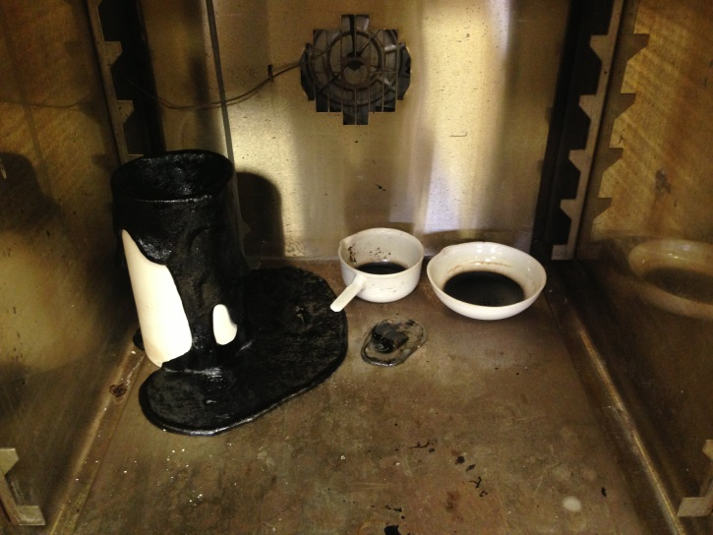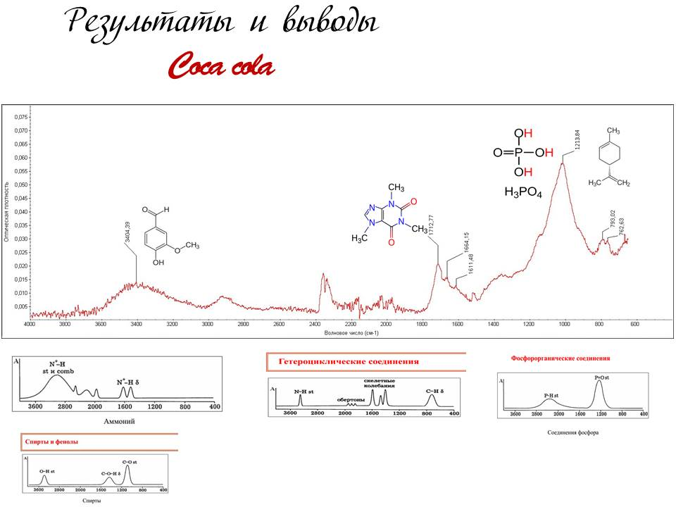

*а.* Nicolet 380 project

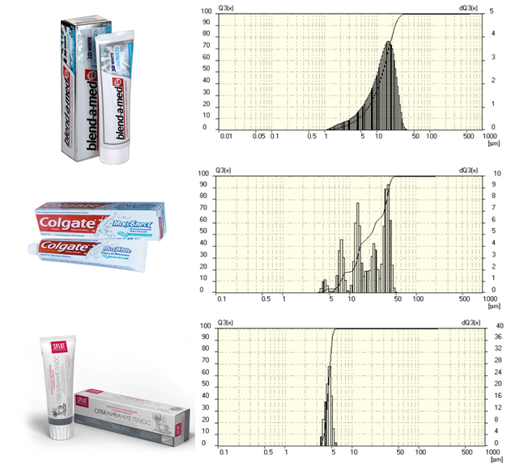

б. FRITSCH Analysette 22 project

Figure 1. Excerpts from the presentations “Intro to Research”

For the next phase - Initiating a Research Project – following generalized research areas were offered to the students: energy efficiency, nanobiotechnology, nanosafety, functional nanomaterials. Students self-divided into groups and proposed the following topics of projects:

1. Modified concrete

2. Deicing coatings

3. Nanopowder based fertilizers for plants

4. Toxicity Nanomaterials

5. Water-repellent spray

6. Electrically conductive polymers

7. Road coatings

The selected concept implies that learning process should simulate the real conditions of modern engineer activity. Therefore, initially there was compulsory requirement to use results of the latest research based on analysis of foreign scientific literature with high citation index.

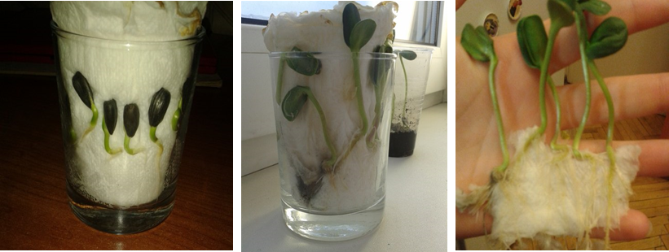

а.

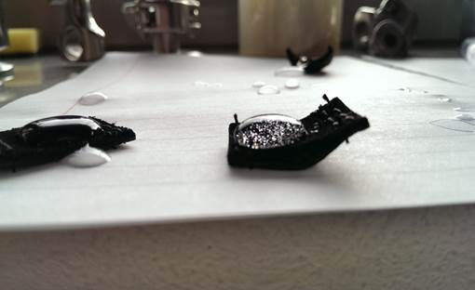

б.

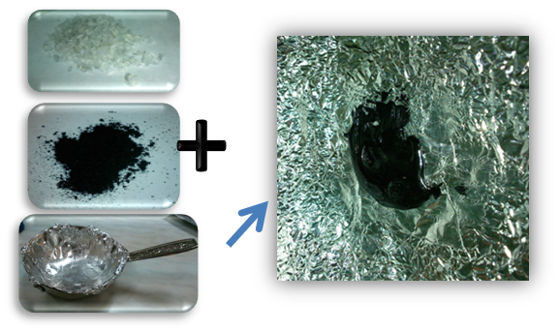

в.

Figure 2. Excerpts from presentations of "initiative researches"

1. Influence of fertilizers on the basis of nanopowders on plants.
2. Analysis of water-repellent properties
3. Development of conducting polymer

The initiative projects results were presented in the framework of the open workshop. By a vote of the invited experts three top teams were identified.

In the anonymous on-line feedback (collected at the end of the semester) the students pointed out that "the acquisition of knowledge and skills are relevant and useful," "opportunity of self-realization" and "take the initiative", "feel as a researcher", develop skills of work on the "real scientific equipment", present projects to the "serious audience, " and do it "first time in English."

Second semester project topics correlated with the themes of individual student research works. Students were asked to create teams by joint topics, which would allow for each student to get maximum useful information and experience for the further research and graduate thesis.

I the framework of “Research Project Based on Profiled Topics” were formulated the following topics:

1. Microstructure and deformation characteristics of the high molecular weight polyethylene films and composites.

2. Biocompatible titanium based implants

3. Metallic wallpapers

4. Management of the Earth's surface insolation level by using semiconductor nanoparticles

5. Nanostructured zirconium alloys, three-dimensional nanomaterials

6. Super pliable brass

7. Preparation of Fe-B-alloy for the production of high purity powerful magnets Nd-Fe-B type

8. Functional coatings based on cobalt nanopowder

9. Use of electrophoresis for rapid vegetables pickling

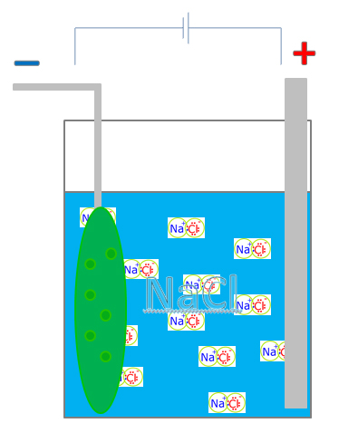

a.

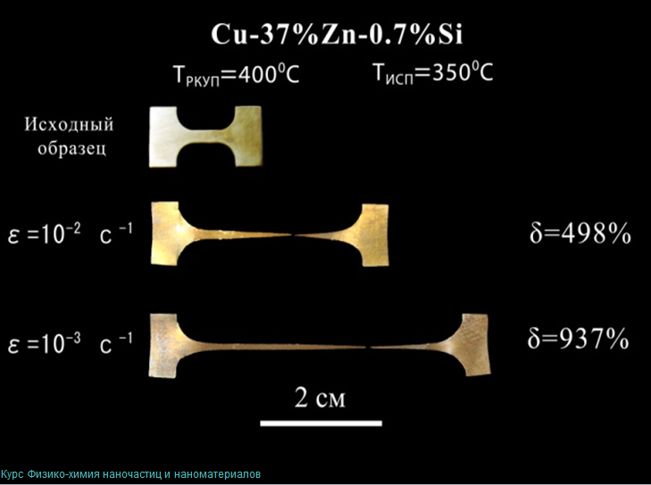

b.

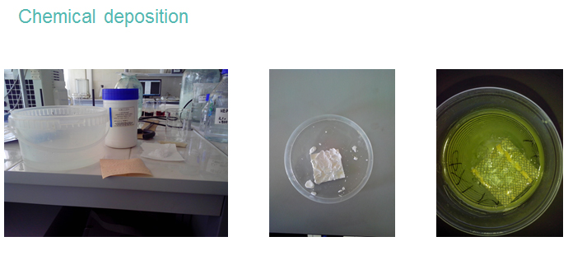

c.

Figure 2. Excerpts from the presentations “Research Project Based on Profiled Topics”

a. Use of electrophoresis for rapid vegetables pickling,

b. Super pliable brass,

c. Metallic wallpapers

To improve presentation skills the project results were presented at the Open seminar of the department and core laboratories. Presentations were made primarily in English. Experts identified three top teams.

An important practical result of the implementation of the PBL approach has become students participation in the "adult" scientific event - competition UMNIK Bortnik Fund ([www.fasie.ru](http://www.fasie.ru)) in April 2014. Despite the fact that none of the submitted projects did not get one of the prizes, both participants and "supporters" have received the skills of presenting the results of their scientific work in this scientific event and the experience of interaction with external independent experts. Within the next selection of the program UMNIK, which took place in October 2014, one of the students win with the research project, which was implemented in the framework of PBL course.

For additional analysis of the achieved knowledge level at the end of the course was held an oral exam, which included standard questions of "classic" curriculum, which showed a good level of course material understanding and developed competencies. As a result of PBL approach implementation can be note following advantages: in the two-semester course students got rich experience in team work and self-tasking, ability to analyze technical problems with the use of modern tools and assess its scientific relevance and feasibility. In terms of engineering skills are no less important experience with real analytical equipment, a deliberate choice of the method of scientific research for the effective solution of the problem, skills of samples preparation using laboratory equipment. An important acquired professional and social competencies necessary to carry the ability to conduct independent research using previously obtained various knowledge and skills to analyze heterogeneous data and submit them to the target audience.

In the context of the required adjustment of teaching methods it seems necessary to strengthen the qualitative and quantitative interaction with the students, including the use of modern means of communication. Communication with students throughout the PBL course is carried out by using resources such as social networks Facebook and Vkontakte, the project management system Tactise, distribution and filling of forms via Google groups and other Google tools. Expansion of the communication quality help to increase the extent of the instructors specific load.

In the same time could be noted some difficulties. There could be some motivation of part of the students, though most of the future engineers take a new format with enthusiasm. A number of students had some difficulties with the organization of group work during the hours of self-study, despite the fact that they were provided space for work and the necessary technical means. The challenge is also a matching students schedule and staffing of complex research equipment. This challenge indicates the need for wider use of virtual laboratories - equipment simulators in the learning process.

Despite these difficulties, in a constant acceleration dynamics of the post-industrial society distribution of PBL in the wider range of future engineers and scientists educational path is an effective and timely.

**REFERENCES**

Borovkov A.I., Burdakov S.F., Klyavin O. I., Melnikova M.P., Palmov V.A., Silina E.N. Modern engineering education: a series of reports. St. Petersburg, 2012. p.2 - 79

Richard K. Miller Beyond Technology: Preparing Engineering Innovators Who Don’t See Boundaries, Franklin W. Olin College of Engineering Needham, 2004

<http://edu.sfu-kras.ru/sites/edu.sfu-kras.ru/files/Mezhdunarodnye_standarty_CDIO_v_obrazovatelnom_standarte_TPU.pdf>

Kerns S.E., Miller R.K., Kerns D.V Designing from a Blank Slate – The Development of the Initial Olin College curriculum (with grateful acknowledgement of the Olin College Faculty). Franklin W. Olin College of Engineering Needham. 2004

Canfield C., Zastavker E.V. Achievement Goal Theory: A Framework for Implementing Group Work and Open-Ended Problem Solving. 40th ASEE/IEEE Frontiers in Education conference. Washington. DC. October 27-30. 2010

Miller R.K., Salmi J. Why So Many Nations Are Fused on Educating Engineering Innovators Today. Franklin W. Olin College of Engineering Needham. MA. 2013

Miller R.K., The Challenge of Spreading Innovation in Teaching and Learning: Why Is It So Hard and What Can Be Done About It? Franklin W. Olin College of Engineering Needham. MA. 2011

Grasso D., Miller R.K.What Does It Mean to Think Like an Engineer—Today? Franklin W. Olin College of Engineering Needham. MA. 2012

[reative Commons License](http://creativecommons.org/licenses/by-nc-nd/3.0/deed.en_US)  
This work is licensed under a [Creative Commons Attribution-NonCommercial-NoDerivs 3.0 Unported License](http://creativecommons.org/licenses/by-nc-nd/3.0/deed.en_US).